Norwich PC Solar Siting Subcommittee DRAFT
September 16, 2025 - Minutes

Subcommittee members present: Mary Gorman, Ernie Ciccotelli, Jaan Laaspere
Steven True, Norwich PD/ZA

Public attending: Linda Gray, Robert Gere, Jim Antal, John Cushman

Meeting started at 6:32

- Approved Agenda - unanimous

- Public comment
Jim Antal and Jack Cushman commented on the importance of solar and high level of public support for renewable energy in Norwich.

- Review Enhanced Energy Plan project components
Gorman read the new subcommittee charge into the record.

True gave an overview of the required sections of the EEP, which are usefully and prescriptively described in the state document included in the packet.

One proposal discussed was to create a separate group composed of PC members, Energy Committee members and Harry Falconer to work on EEP sections relating to background data and perhaps other sections. The full Planning Commission would be responsible for planning topics such as land use policy as they impact energy topics.

The breakdown of these EEP tasks, along with the possible creation of a joint group with the EC, will be on the agenda for the October PC meeting.

- Review and discuss EEP actions in Pathways #9
We reviewed Pathways Standard #9 of the state EEP guiding document relating to renewable energy siting. This section will be the focus of this solar siting group:
9A - Existing renewable energy generation
9B - Renewable generation potential => link to mapping
9C - Identify sufficient land to meet 2050 target
9D - Constraints related to meeting targets
9E - Policies, objectives and siting guidelines
9F - Maximize potential on preferred locations
9G - Municipal projects
9H - Other
Wind was briefly discussed and determined to be a much lower priority for Norwich siting activity, given our topography and the realities of utility scale wind power in VT.

We decided to start with a first pass at the mapping exercise.

- Review & Discuss Mapping Requirements
To guide the discussion on items #9 A – H this group will start with an initial mapping exercise.

During this exercise we will clearly identify the assumptions and open questions, such as the particular value of steep slopes being mapped as a constraint layer or distance from 3-phase power where a PV project is still viable.

This spectrum from the state document [pg. 42] for mapping siting areas ranging from preferred to unsuitable is a useful graphic. The specifics listed in each category are taken to be simply examples, not an inclusive list.

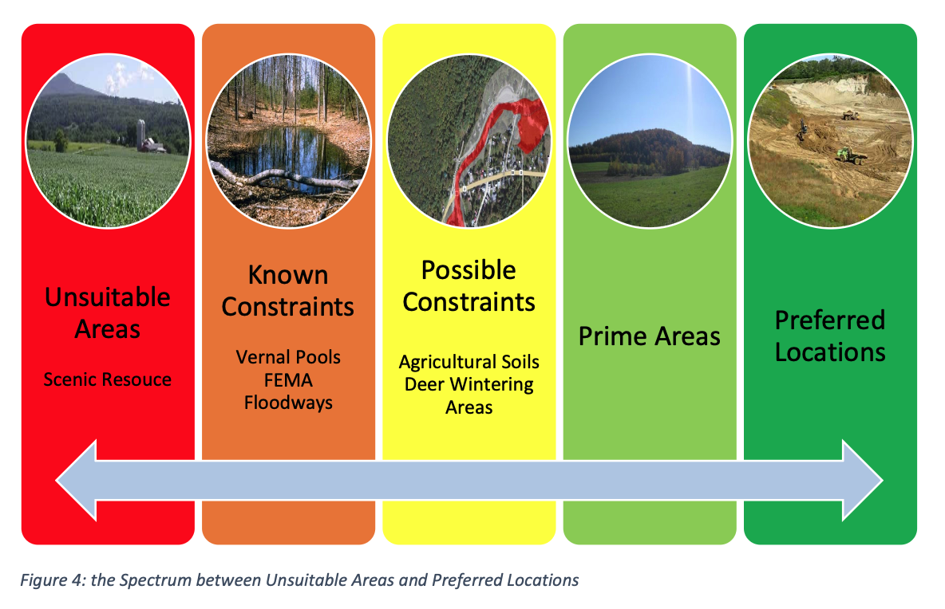

True will include preliminary mapping results into next meeting packet.

- Approved minutes of July 22, 2025 - Unanimous

Meeting adjourned at 8:02

Next meeting scheduled for October 21, 2025 to review maps and related assumptions.

Minutes submitted by Jaan Laaspere

